Newport Elks 273 3rd Annual Kids with Cancer Car and Bike Show
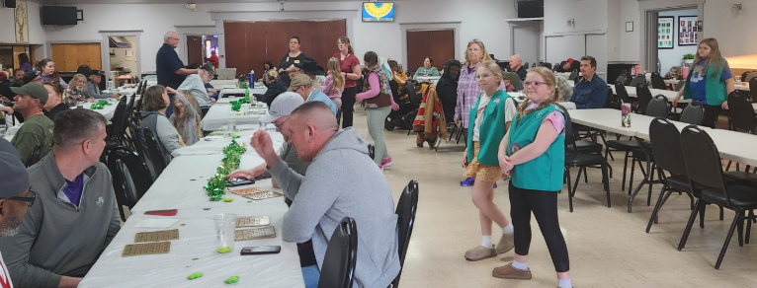
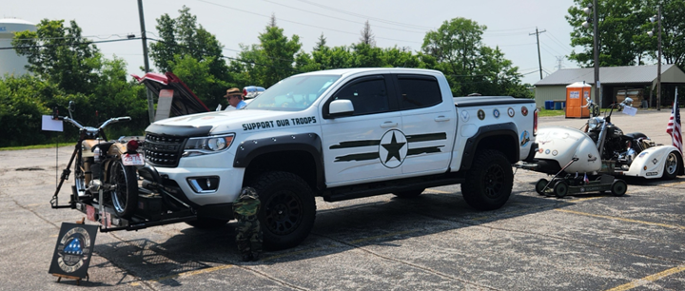
Jim and Candy Staubach hosted our 3rd Annual Kids with Cancer Car and Bike Show. It was a great day to have a car show and we were able to raise $1,446 for Kids with Cancer through entry fees, food and raffles. The Mayor of Cold Spring was our guest judge. We awarded 5 trophies to our winners that included Best Modern, Classic, Motorcycle and Mayor Choice.
Newport Elks 273 Monthly Vets Visits
Every 4th Tuesday of the month, Newport Elks hosts our local vets from Newport and Ft. Thomas. Each visit the Vets receive a fresh cooked meal from our volunteers, play their luck with Bingo and have great conversation with our members. We also have the local Girl Scouts come out and talk with the Vets. Three times a year our group will also put together care packages for our vets to make their day a bit brighter. We used the Beacon Grant to help fund the food, care packages and holiday gifts throughout this year’s activities with our local Vets.
Newport Elks 273 Scholarship Committee
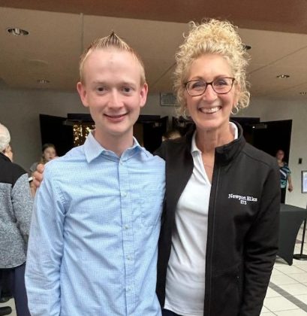
The Newport Elks Scholarship Committee (Ray Pauly, Cathi Hildebrand and Donna Hanson) had a very busy year with 28 applications received for the Most Valuable Student Scholarship Program and 35 applications received for the Newport Elks College Aid Grant Program. The Committee selected the top nine Most Valuable Students to receive local awards of $1,000 each and eight students received College Aid Grants between $500 and $1,000 each for a total of $16,000 in funding for graduating high school seniors in 2025. The Newport Elks Lodge is also very proud that four of the five students from Kentucky to receive Legacy Awards were sponsored by the Newport Elks Lodge. \
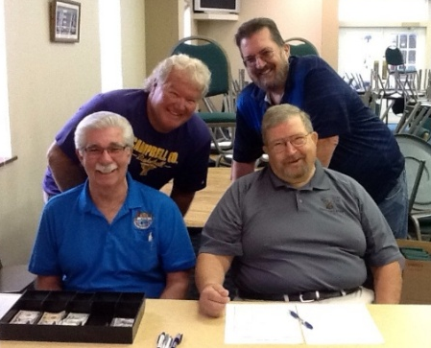
Newport Elks 273 Golf Stag
This year’s Golf Stag was a huge success with 31 4’somes participating. This was a great fundraiser for our Elks with a total income of more than $10,000 for the day. Dave Orth and Mark Kuntz did a great job building the committee that made this event come to life.

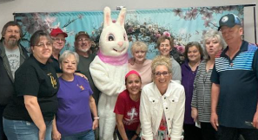
Newport Elks 273 Breakfast with the Easter Bunny
On April 5th we had Breakfast with the Easter Bunny and Drug Awareness Event. There were over 100 people registered and quite a few walk-ins, thanks to the rain. Over 50 Drug Awareness packets were given out. It was a really great time. The kids had a blast at the craft table and at the photo booth.
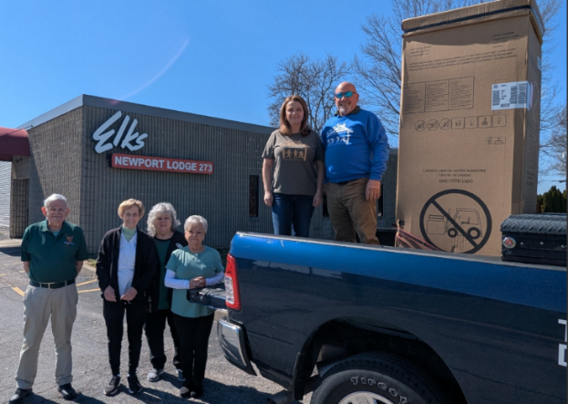
Newport Elks 273 Barracks Project
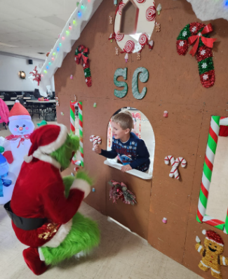
The Newport Elks partnered with the Barracks Project to help with their renovation project to convert a one unit dwelling for a homeless Vet into a two-unit dwelling. The Barracks Project is a non-profit organization that relies on donations to meet the needs to homeless Vets in our community. With funds from the Freedom Grant, we were able to purchase the washer/dryer combo that helped to complete this unit.
Newport Elks 273 Breakfast with Santa
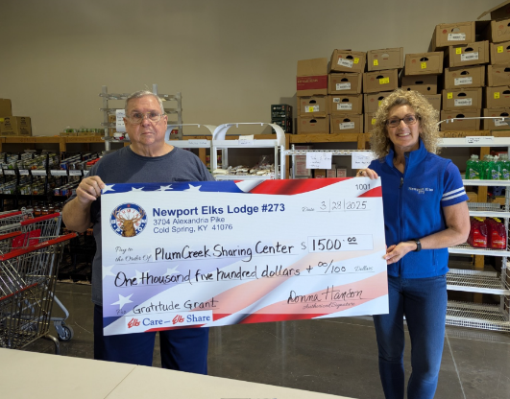
Candy Staubach had another successful Breakfast with Santa. The Grinch even made a surprise visit which was a huge delight for the kids. This event gets bigger each year as Candy spends the off season creating something new to add to the experience for the kids, and this year she added Gingerbread House which was the entry into the path where Santa and Mrs. Claus were waiting to meet the children.
Newport Elks 273 Helps to Fight Food Hunger
The Newport Elks used their Gratitude Grant to donate funds to keep the grocery shelves stocked at two local food pantries. These funds will be used to purchase the most requested items for individuals and families who visit the St. Vincent de Paul Food Pantry and The Sharing Center at Plum Creek.
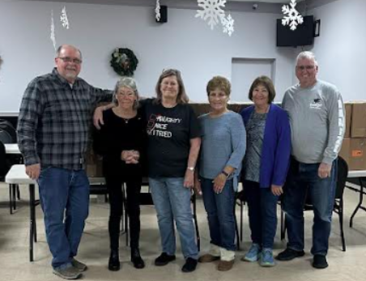
Newport Elks Spotlight Grant with the Ladies Auxiliary
The Ladies Auxiliary coordinated the donation of personal hygiene and cleaning products to needy families in the Dayton Independent School District in December 2024.

